 

CS-114 Fundamentals of Programming (2+1)

DE-41 EE Semester 1

Fall 2019

**LAB REPORT # 07**

|  |  |
| --- | --- |
| **Submitted by** | **Roll No** |
| Ayesha Javaid | 285151 |
| Syndicate A |  |

Instructor In-charge: Dr. Saad Rehman

DEPARTMENT OF COMPUTER & SOFTWARE ENGINEERING

College of Electrical and Mechanical Engineering (CEME)

National University of Sciences and Technology (NUST)

**Lab Number: 6**  
**Lab Title: Arrays**  
**Aim:**

**To get the better understanding of ARRAYS.**

**Topic(s) covered: ARRAYS.**

**(Tasks starting from next page)**

**TASK 1:**

**Write a program that asks for the number of hours worked by six employees. It stores the values in an array. Display the values of array too.**

**Code:**

#include <iostream>

using namespace std;

int main()

{

int num[6];

for (int i = 0; i < 6; i++)

{

cout << "enter number of hours worked by employer: ";

cin >> num[i];

}

for (int i = 0; i < 6; i++)

{

cout << num[i] << endl;

}

system("pause");

return 0;

}

**OUTPUT:**

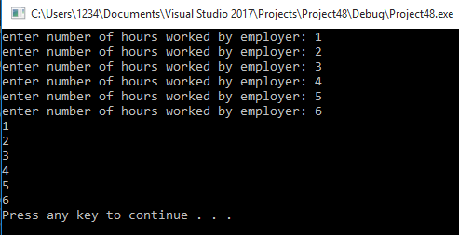

**TASK 2:**

Take 10 integer inputs from user and store temperature in Celsius in it then convert the temperature to Fahrenheit and store it in another array also display it.

**CODE:**

#include<iostream>

using namespace std;

int main()

{

int temp[10];

double celsius;

double Fahrenheit[10];

for (int i = 0; i < 10;i++)

{

cout << "temperature in celsius: ";

cin >> temp[i];

celsius = temp[i];

Fahrenheit[i] = (celsius * 1.8) + 32;

cout << "temperature in farhenheit " << Fahrenheit[i] << endl;

}

for (int i = 0; i < 10;i++)

{

temp[i] = Fahrenheit[i];

cout << temp[i] << endl;

}

system("pause");

return 0;

}

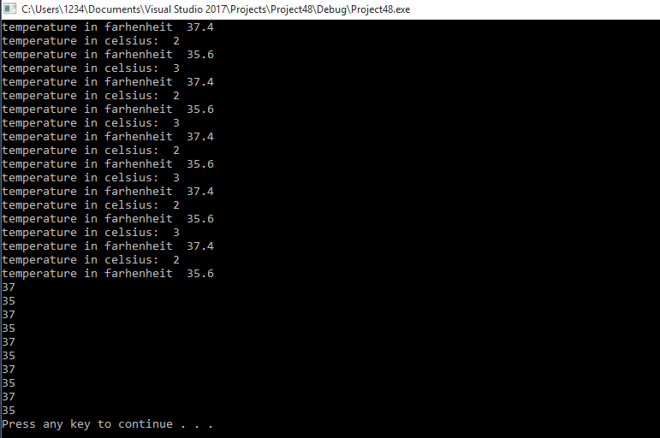

**TASK 3:**

Write a function, which finds the last occurrence of the minimum value in an integer array.

**CODE:**

#include<iostream>

using namespace std;

int main()

{

int a[] = { 9,3,2,3,4,2,5,2,8};

int min;

int last_occurance = 8;

min = a[8];

for (int i = 8;i >= 0; i--)

{

if (min > a[i])

{

min = a[i];

last_occurance = i;

}

}

cout << "last occurance is " << last_occurance << endl;

system("pause");

return 0;

**}**

**OUTPUT:**

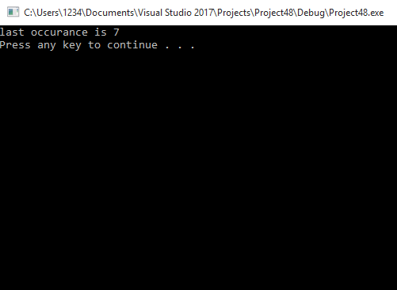

**TASK 4:**

Write a program, which receives two matrices, and display the result of addition of two given matriceson console.

**CODE:**

#include<iostream>

using namespace std;

int main()

{

int a[3][3];

int b[3][3];

int sum[3][3];

cout << "enter elements of matric A: " << endl;

for (int i = 0; i < 3; i++)

{

for (int j = 0; j < 3;j++)

{

cin >> a[i][j];

}

}

cout << "enter elements of matric B: " << endl;

for (int i = 0; i < 3; i++)

{

for (int j = 0; j < 3;j++)

{

cin >> b[i][j];

}

}

cout << "sum of A and B: " << endl;

for (int i = 0; i < 3; i++)

{

for (int j = 0; j < 3; j++)

{

sum[i][j] = a[i][j] + b[i][j];

cout << sum[i][j] << " ";

}

cout << endl;

}

system("pause");

return 0;

}

**OUTPUT:** 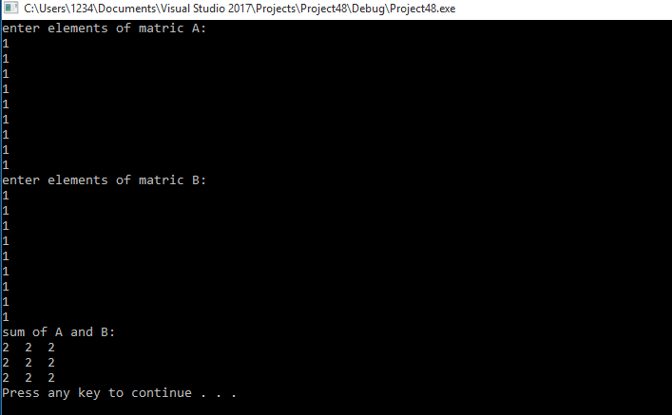

**TASK 5:**

Write a program to find the transpose of a matrix.

**CODE:**

#include<iostream>

using namespace std;

int main()

{

int a[3][3];

int b[3][3];

cout << "enter elements of matrix A: " << endl;

for (int i = 0; i < 3; i++)

{

for (int j = 0; j < 3;j++)

{

cin >> a[i][j];

}

}

cout << "Matrix A is:" << endl;

for (int i = 0; i < 3; i++)

{

for (int j = 0; j < 3;j++)

{

cout << a[i][j] << " ";

}

cout << endl;

}

cout << "Transpose of matrix of A: " << endl;

for (int i = 0; i < 3; i++)

{

for (int j = 0; j < 3;j++)

{

b[i][j] = a[j][i];

cout << b[i][j] << " ";

}

cout << endl;

}

system("pause");

return 0;

}

**OUTPUT:**

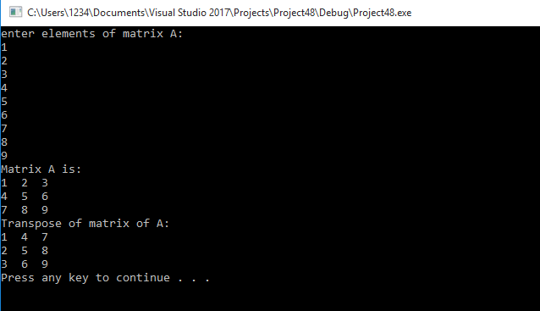

**TASK 6:**

Write a program, which receives two matrices, and display the result of multiplication of two given matrices on console.

**CODE:**

#include <iostream>

using namespace std;

int main()

{

int matrix1[2][2] = { 2,3,4,5 };

int matrix2[2][2] = { 2,3,4,5 };

int multiply[2][2] = { 0,0,0,0 };

for (int i = 0; i < 2;i++)

{

for (int j = 0; j < 2;j++)

{

for (int k = 0;k < 2;k++)

{

multiply[i][j] += matrix1[i][k] * matrix2[k][j];

}

}

}

for (int i = 0; i < 2;i++)

{

for (int j = 0; j < 2;j++)

{

cout << multiply[i][j] << " ";

}

cout << endl;

}

system("pause");

return 0;

}

